# Scintilla.NET can’t be loaded in Terminals

## Introduction

Bug in Scintilla.NET version 2.5.2 Scintilla.cs line 669:

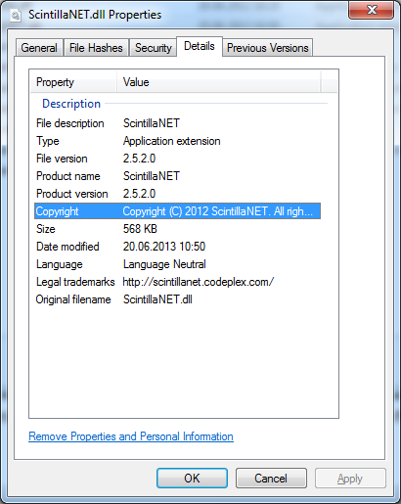

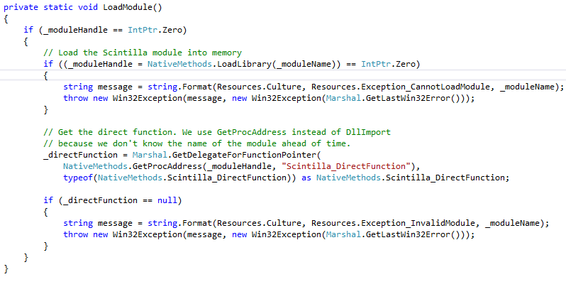

## Symptoms

Terminals plugin is unable to load the scintilla native component and produces an error in the Terminals log like:

**ERROR 2013-06-20 15:32:50,561 51427ms Terminals Error - System.ComponentModel.Win32Exception: Cannot load the 'SciLexer.dll' module into memory. ---> System.ComponentModel.Win32Exception: The specified module could not be found**

**--- End of inner exception stack trace ---**

**at ScintillaNET.Scintilla.LoadModule() in C:\Users\jslusser\Projects\ScintillaNET\Releases\2.5\ScintillaNET\Scintilla.cs:line 669**

**at ScintillaNET.Scintilla.get_CreateParams() in C:\Users\jslusser\Projects\ScintillaNET\Releases\2.5\ScintillaNET\Scintilla.cs:line 2508**

**at System.Windows.Forms.Control..ctor(Boolean autoInstallSyncContext)**

**at System.Windows.Forms.Control..ctor()**

**at ScintillaNET.Scintilla..ctor() in C:\Users\jslusser\Projects\ScintillaNET\Releases\2.5\ScintillaNET\Scintilla.cs:line 3688**

**at CodeEditor.Edit.InitializeComponent() in d:\Kohl\Projects\Code\Terminals\CodeEditor\Edit.Designer.cs:line 123**

**at CodeEditor.Edit..ctor() in d:\Kohl\Projects\Code\Terminals\CodeEditor\Edit.cs:line 696**

**ERROR 2013-06-20 15:32:50,570 51436ms Terminals Error - System.NullReferenceException: Object reference not set to an instance of an object.**

**at CodeEditor.Edit.SetScintillaToCurrentOptions(Scintilla scintilla) in d:\Kohl\Projects\Code\Terminals\CodeEditor\Edit.cs:line 563**

**at CodeEditor.Edit.NewDocument() in d:\Kohl\Projects\Code\Terminals\CodeEditor\Edit.cs:line 324**

**at CodeEditor.Edit..ctor() in d:\Kohl\Projects\Code\Terminals\CodeEditor\Edit.cs:line 705**

**ERROR 2013-06-20 15:32:52,437 53303ms Terminals Error - System.NullReferenceException: Object reference not set to an instance of an object.**

**at CodeEditor.Edit.SetLanguage(String extension) in d:\Kohl\Projects\Code\Terminals\CodeEditor\Edit.cs:line 77**

## Solution

If the build in solution Terminals uses doesn’t work please be so kind to report the error and use one of the below mentioned solutions (solution one to three) - every solution except solution number four.

### Solution 1:

Change the line 669 in Scintilla.cs:

from



to

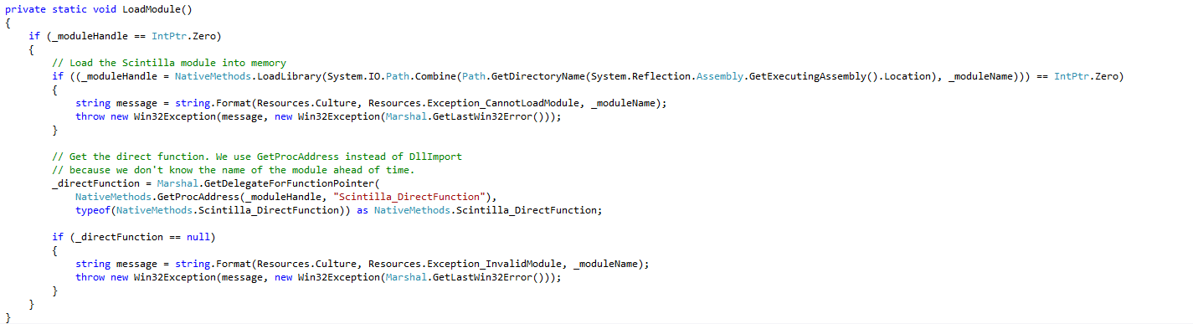

### Solution 2:

Move or copy the Scintilla.NET dependent libraries to the Terminals root directory:

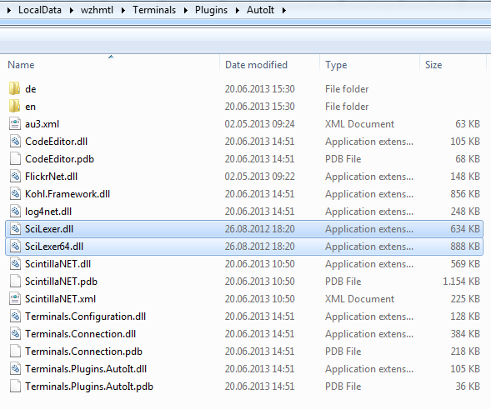

### Solution 3:

Move or copy the Scintilla.NET dependent libraries to the System32 and SysWow64 directories.



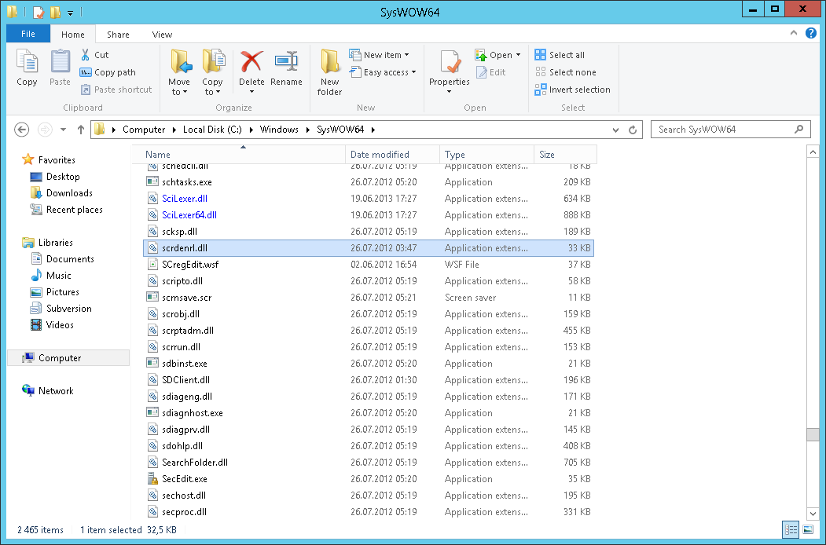

### Solution 4 (default, built-in)

Terminals try to work around this problem by using the following code in the “Terminals code editor”

🡪 Workaround: Load SciLexer or SciLexer64 before the Scintilla.NET library does.

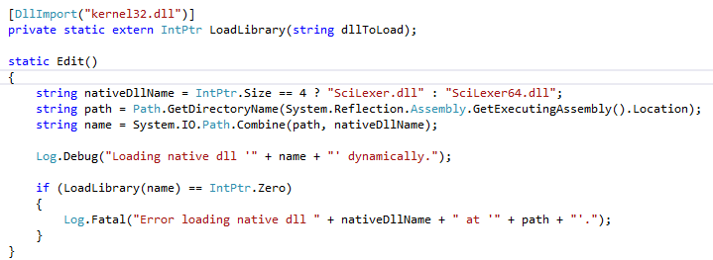

# Notifying the developer

Either navigate to the website

<http://www.kohl.bz>

or

write an e-mail to

[oliver@kohl.bz](mailto:oliver@kohl.bz)

and report the issue, possible root causes and symptoms.